SECTION 2.13 RECOGNISED FLIGHT TIME AND/OR QUALIFICATONS FROM ORGANISATIONS OTHER THAN RAAus
Page 74

Paragraph 1, meaning of recognised flight time

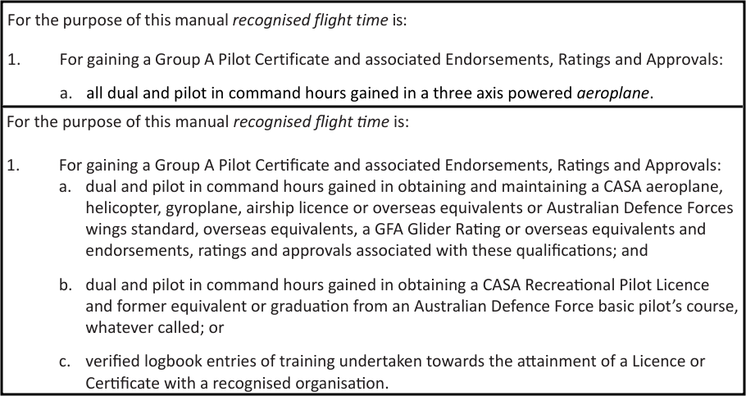

SECTION DEFINITIONS
Page 10

- Definition of Aeroplane added, which corresponds to the definition applied in the Civil Aviation Safety Regulations (CASR).
- Definition of Aircraft added.
- Definition of Touring Motor Glider added.

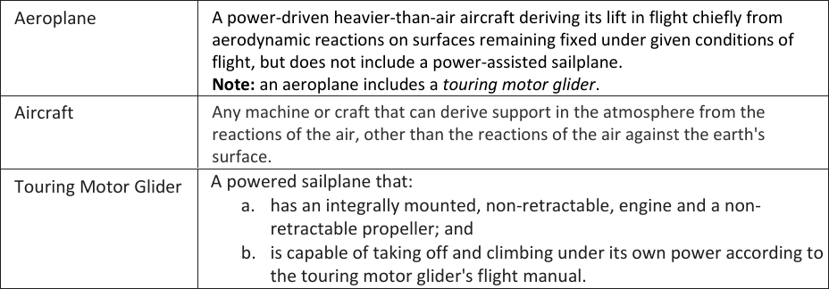

SECTION ALL SECTIONS

The term “aeroplane” has been replaced with the term “aircraft”, except where the term aeroplane is required in accordance with the updated definition.

SECTION 2.13 RECOGNISED FLIGHT TIME AND/OR QUALIFICATONS FROM ORGANISATIONS OTHER THAN RAAus
Page 74

Paragraph 9. b. (iii). has been removed, which permitted a reduction to 25 hours Pilot in Command of an aircraft which can be RAAus registered as a minimum aeronautical experience for the issue of an instructor rating.

